**ONLINE CAR RENTAL MANAGEMENT SYSTEM**



**NUNNA LAKSHMI MANASA(AP19110010382)**

**TANMAYEE CHANDANAM(AP19110010402)**

**RISHITHA CHILKURI(AP19110010441)**

**DECLARATION:**

We hereby declare that the project work entitled

**“ONLINE CAR MANAGEMENT SYSTEM”** has been carried out by our own efforts and facts arrived at our observation under the guidance and motivation of our mentor **“Mr.Sanjeev Kumar”**.

**Name: Manasa**

**Class: B-Tech 2nd Year**

**Branch: CSE-F**

**Roll no: AP19110010382**

**Name: Tanmayee**

**Class: B-Tech 2nd Year**

**Branch: CSE-F**

**Roll no: AP19110010402**

**Name: Rishitha**

**Class: B-Tech 2nd Year**

**Branch: CSE-F**

**Roll no: AP19110010441.**

**ACKNOWLEDGEMENT:**

We would like to express our zeal and gratitude

to our mentor **“*Mr.Sanjeev Kumar*”** for their able guidance and support in successful completion of our project on “***ONlINE CAR RENTALS***” which helped us in doing a lot of research and we came to know about many things through our entire project that we are really thankful to him. Also we were able to increase our knowledge and enhance our skills. Secondly we would like to thank our friends and parents for their opinions on our project which helped us in finalizing the project within the limited time period.

**Nunna Manasa**

**Tanmayee Chandanam**

**Rishitha Chilkuri.**

**ABSTRACT:**

Car rental is a company specializing in renting cars to customers in which customers can register, view available cars, and book cars through an online system. Also through which customers can reserve available cars online before their expected pick-up date or time and use them temporarily for a fee during a specified period. This software car Rental This software car Rental System has a very user-friendly interface. Thus the users will feel very easy to work on it. Using this system admin can manage their rental, payment, employment issues, and vehicle issues such as insurance. The car information can be added to the system. Or existing car information can be edited or deleted too by the Administrator. The transaction reports of the car rental system can be retrieved by the admin when required. Thus, there is no delay in the availability of any car information, whenever needed, car information can be Captured very quickly and easily.

**ALGORITHM:**

1. Start
2. Create home page for online rentals
3. Create signup and login pages
4. Also, create contact, about us html pages and connect them through hyperlinks.
5. Add all the above fields on the home page.
6. Create a car’s information page for the users to get them through the knowledge of cars.
7. Create a database of cars for tables
8. Create a table user to know the number of users registered.
9. Create a table permission and add the requirements to know who are eligible to make use of our system.
10. Create a table caravail to keep track of cars and their availability.
11. And then through car booking html page users can enter their specifications and book the car.

**TABLE OF CONTENTS:**

1. **INTRODUCTION**

**1.1 Objective**

**1.2 Scope of the project**

**1.3 Overview of the project**

1. **Overall description**
2. **User requirements**
3. **System requirement specification**

**4.1 Non-functional system requirements**

**4.1.1 Performance requirements**

**4.1.2 Safety requirements**

**4.1.3 Security requirements**

1. **Hardware requirements**
2. **Software requirements**
3. **Code**
4. **Sample input and output**
5. **Conclusion and recommendations**
6. **Future scope**

**1.** **INTRODUCTION:**

**1.1 OBJECTIVE:**

Car rental is a company specializing in renting cars to customers in which customers can register, view available cars, and book cars through an online system. Also through which customers can reserve available cars online prior to their expected pick-up date or time and use them temporarily for a fee during a specified period and create a platform online through which people can rent the cars and make use of them at any time. The main purpose of the Car Rental System is to manage the details of Car, Payment, Customer, Supplier, etc**.**

**1.2 SCOPE OF THE PROJECT:**

The car rental system keeps detailed records of both the cars and the customers, the duration they rent a car as well as the type of car they rent.

* The system will be mainly designed for a small company that renders its car rental services to customers.
* The system will have the ability to generate and print invoices for each successful transaction.

**Level of Access:**

The system will have two levels of access:

1. The Administrator
2. Customer

**1.3 OVERVIEW OF THE PROJECT:**

An online car rental system allows a person to book/reserve a vehicle with/without payment on one end while the company staff handles the transactions, on the other via the Internet.

The basic functions of an online car rental system are to keep tracks of vehicles, staff, customers and booking. It provides useful information to the staff such as giving daily reports of vehicles to be delivered/picked up and acts as a vehicle management system by monitoring the use and price of the vehicles.

**2.OVERALL DESCRIPTION:**

This Car Rental System project is designed to aid the car rental company to enable renting of cars through an online system. It helps the users to search for available cars, view profiles and book the cars for the time period. It has a user-friendly interface which helps the user to check for cars and rent them for the period specified. They could also make payment online. The rental cars shall be categorized into economy, premium etc. Based on the type of car required by the customer, the user shall be able to make bookings. The use of internet technology has made it easy for the customers to rent a car any time. This Car Rental System makes the bookings easy. It saves time and labor. The tool shall ask the user for information such as the date and time of journey, type of car etc. Also, it will need an identification number. Using these details, the tool shall help the customer to book a car for the journey.

**3.USER REQUIREMENTS:**

a)Car rental agencies should have a collection of cars.

b)Each car should belong to a particular Car Category and each car will belong to a particular location.

c)Customer, based on his location and car category preferences, rents a car.

d)Based on his location and car category preferences, a list of cars available to rent will be shown along with available date and time(from and to).

e)Customers will select a car from the suggestions and should be able to reserve it for rent.

f)When a customer reserves a car, he/she should be able to optionally purchase a Car Insurance Plan and should be able to apply at most one discount code.

g)If a customer is also a member of the car rental agency and has a membership ID then he/she will be given a default 10% discount in addition to the discount code applied.Therefore the total discount percentage will be 10 plus the discount percentage given by the discount code applied.

h)Billing is generated when a car is returned.

i)Customer can return the car before the due date, on the due date or he/she can return it late also.

j) If a customer returns a car after the due date, additional late fee is calculated and added to the bill.

k) A default 8.25% tax is applied on the amount which also includes the late fee and this tax is added to obtain the total amount to which the discount will be applied and a final amount is obtained.

l) Once the car is returned it becomes available for booking.

m) a booking can be cancelled until 5 days before the actual pickup.

n) Companies may have several discount plans like weekend discounts, corporate discounts etc.

o) Car price will be calculated based on the selected make and model.

**4.** **SYSTEM REQUIREMENTS SPECIFICATIONS:**

**4.1 FUNCTIONAL SYSTEM REQUIREMENTS:**

**Functional Requirements**

**Hardware Requirements:**

The software should be ran on any sort of desktop or laptop environment, regardless of the operating system. The software also has the potential of running on tablets, but with a more simplified version. Essential input/output devices are keyboards, mouse, and printers; nothing else is required but can be recommended if desired.

**Website Interface- Primary Tasks:**

● View all available rental cars

○ Connects with the database through JavaScript to call all car objects and display them accordingly

● Search for desired car by model, seating capacity, and cost

○ A search bar will be implemented on the website that will search the site based on the input

● Select their desired rental car

○ A button will be displayed under the rental car previews that will allow for the selection

● Allow for registration

○ registration display form

● Allow the customer to log in

○ log in display form

● Allow administrators to change what cars are available for rent

○ Administrators will login through the login display form such as customers would, but would have a different looking interface to allow for them to add and remove options.

**Website Interface- Secondary Tasks:**

● Allow for rent cancellation by customer

○ Only for users who are registered,there were be a cancel button on the display page that shows all rents present by customer

● Allow the user select and provide a payment type

○ Display form- with options for typical card information- type,number,code on back,month,year etc.

● Authenticate any user logging in

○ communicates with the database to verify the inputted username and password is correct

● Authenticate any form of payment

○ communicates with verifiers to confirm the input information on the card is correct

● Calculate tax rates,customer totals

○ algorithms implemented within the code that will calculate all totals ‘behind the scenes’

● Send an email to verify a registration

○ Once a customer registers and click the complete registration button, an email will be sent to the email the customer provided, provided a link in the email that will allow for a verification that this is the said-customer.

● Display a transaction summary/email a summary

○ after customer submits their payment and it is confirmed client-side,a transaction summary will display on the website and a copy will be emailed to the customer

● Select date of desired delivery(& choose delivery destination),or date of planned pickup at nearest store location

○ Calendar options will be displayed that will allow the user to select directly on the calendars- if they want it as soon as possible,there will be a checkbox for that option

● Select length of rental and planned drop-off date

○ Calendar options as well

● Store customer information in the database

○ When registering, the customer will provide their information in the form - this information will be sent securely sent and stored in the database

**Company-side Software - Primary Tasks:**

● Allow company workers to open and view customer information

○ navigation option that will allow for search of customer by name or rental car

○ implementation of search bar

● Track customer payments

○ displays with the customer’s information

● Keep and display available rental car records (for damages purposes and such)

○ Searching and viewing much like with customers

**Company-side Software - Secondary Tasks:**

● Print invoice

○ if print option is selected, a printable version of the page being viewed by the worker will display with a confirm print button to selected printer

● Calculate total of all transactions

○ algorithms behind the scenes

● Allow for rent cancellation by company worker

○ a button will cancel a rent request by a customer

**4.2 NON-FUNCTIONAL SYSTEM REQUIREMENTS:**

**Performance Requirements:**

● Ability to maintain mass amount of customers on the website at once without crashing

● Speedy performance/transmission of data

● Send any emails immediately

● Being logged in should allow for customers to quickly make payments without reentering information, and allow for any potential registered perks the company may have

● Have a quick recovery time if anything were to go wrong

● Display accurately and efficiently on all devices (responsive view)

**Security Requirements:**

● Secure any transmissions of private information between the customer and the company

● Prevent any potential threats such as SQL injections through the forms or search boxes.

● Prevent third party users at administration level

● Verify website security certificates (that lock in the address bar)

● Prevent false information from being used as payment

● Prevent false email inputs from being used when registering

**Quality Attributes:**

● Maintain a user friendly environment that is visually appealing

● Easy to see and use navigation

● Maintain readable content

● Searching cars should be accessible to people who are and are not logged in

● Selecting and making a payment should be available to customers who are and are not logged in

**4.** **HARDWARE REQUIREMENTS:**

*Dual Core processor or above

*512 MB RAM or above

*100 GB HARD DISK or above

*IIS Server

**5.** **SOFTWARE REQUIREMENTS:**

*Visual Studio.Net 2010

*MySQL.

It is an open-source database with its proven performance reliability and ease of use MySQL has become the leading database choice for web-based applications.

In order to develop a full website in which users can practically register and avail the services provided, we built it using Html, CSS, Javascript in the front-end, and in the back-end, we use a database management system to store all the data.

*Windows XP or above

**6.CODE:**

***# Home Page:***

<!DOCTYPE html>

<html>

<head>

<title>Vehicle rental management system</title>

<meta name="viewport" content="width=device-width, initial-scale=1">

<link rel="stylesheet" href="https://cdnjs.cloudflare.com/ajax/libs/font-awesome/4.7.0/css/font-awesome.min.css">

<style type="text/css">

.strip{

background-image: linear-gradient(180deg, #738f9b 50%, #738f9b 50%, #738f9b 100%);

background-size: 40.00px 40.00px;

}

.hand {

cursor: pointer;

}

.home_content{

background-image: url("./homepage_car.jpg");

background-repeat: no-repeat;

background-attachment:fixed;

background-size: cover;

}

.super_top{

margin-left: 150px;

margin-right: 150px;

}

.top_bgr {

background-image: url("./feedbackbg.jpg");

color: white;

background-size: cover;

}

.site_heading{

font-size: 250%;

float: left;

text-decoration: none;

font-weight: bold;

}

.btn {

background-color: #738f9b;

border-color: white;

color: white;

}

a{

color: #738f9b;

}

body{

font-family: Cambria;

color: #738f9B;

margin: 0px;

}

ul {

list-style-type: none;

padding: 0;

overflow: hidden;

}

li {

float: right;

font-size: 125%;

padding: 15px 0px 0px 0px;

border: 0px;

}

</style>

</head>

<body>

<div class="super_top">

<ul>

<li class="site_heading hand" style="transform: scale(1);">CAR RENTALS</li>

<a href="./yetToDesign.html" target="_blank">

<li class="hand" style="font-size: 115%; transform: scale(1); margin-top: 18px">

<img src="./q_mark2.png" width="20px" height="22px" style="float: left; opacity: 80%">

&nbsp;Support centre

</li>

</a>

</ul>

</div>

<div class="strip">

<ul class="super_top" style="color: white; margin-bottom: 0px;">

<a href="file:///C:/Users/KrishnaMohanN/Downloads/Car%20Rental/login.html">

<button class="hand btn" style="float: right;margin-top: 15px; margin-bottom:

15px;font-size: 125%;font-family:Cambria; border-radius: 5px;">LogIn</button>

</a>

<a href="file:///C:/Users/KrishnaMohanN/Downloads/Car%20Rental/sign-up.html">

<button class="hand btn" style="float: right;margin-top: 15px; margin-bottom:

15px;font-size: 125%;font-family:Cambria; border-radius: 5px;">Signup</button>

</a>

<a href="file:///C:/Users/KrishnaMohanN/Downloads/Car%20Rental/aboutus.html" target="_blank" style="color: white">

<button class="hand" style="float: left; padding-bottom: 17px; padding-top: 17px;

">About us</button>

</a>

<a href="file:///C:/Users/KrishnaMohanN/Downloads/Car%20Rental/bootstrap-3-contact-form/contact.html" target="_blank" style="color: white">

<button class="hand" style="float: left; padding-bottom: 17px; padding-top: 17px;

">Contact</button>

</a>

</ul>

</div>

<div class="home_content">

<p style="color : red; font-family: Georgia; margin-left: 55px; margin-top: 0px; margin-right:

55px;padding-top: 50px; padding-bottom: 75px;">

<marquee>Important Update : We are delighted to inform you, that we have

resumed our self-drive vehicle rental services , across all cities in India. We as a responsible

business and your trusted mobility partner, is taking all necessary safety precautions , to ensure a safe ride for

you during this pandemic</marquee><br><br>

<span style="color: black; padding-left: 225px;font-family: arial;font-size:

185%">Your safety is our priority - Car rentals is your partner in safe travel</span><br><br>

<span style="color: red; padding-left: 415px; font-family: arial;font-size:

125%">To ensure you travel safely, we have taken strict Covid-19</span><br>

<span style="color: red; padding-left: 490px; font-family: arial;font-size:

100%">safety measures to keep all our customers safe</span>

<div style="margin-left: 95px;padding-left: 415px; font-size: 110%; font-style:

italic; padding-bottom: 200px;">

&#10003; &nbsp; <span style="color: black">Disinfecting vehicles before & after each

ride.</span><br>

&#10003; &nbsp; <span style="color: black">Equipping vehicles with hand sanitizer &

disinfectants.</span><br>

&#10003; &nbsp; <span style="color: black">Users should wear masks & gloves at

all times.</span>

</div>

</p>

</div>

<div class="strip" style="color: white; font-size: 90%">

<div style="margin-left: 150px">

<ul style="margin: 0px">

<a href="file:///C:/Users/KrishnaMohanN/Downloads/Car%20Rental/terms.html" target="_blank" style="color: white">

<li class="hand" style="float: left; padding: 16px;">Terms & Conditions</li>

</a>

<a href="file:///C:/Users/KrishnaMohanN/Downloads/Car%20Rental/privacypolicy.html" target="_blank" style="color: white">

<li class="hand" style="float: left; padding: 16px;">Privacy Policy</li>

</a>

<div style="margin-right: 150px; ">

<li style="padding: 5px">

<a href="https://www.facebook.com" target="_blank" >

<i class="fa fa-facebook-square" style="font-size:24px;color:white"></i>

</a>

</li>

<li style="padding: 5px">

<a href="https://in.linkedin.com/" target="_blank" >

<i class="fa fa-linkedin-square" style="font-size:24px;color:white"></i>

</a>

</li>

</div>

</ul>

</div>

<hr>

<center>

<span style="font-size: 110%">&copy; Copy rights reserved</span><br><br>

</center>

</div>

</body>

</html>

**Output:**

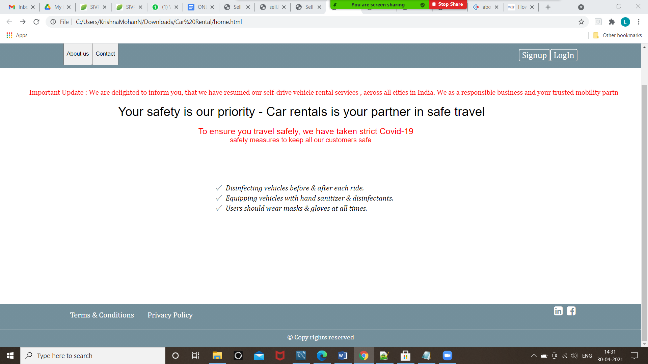

***# About Us Page:***

<!DOCTYPE html>

<html>

<head>

<meta name="viewport" content="width=device-width, initial-scale=1">

<link href="https://fonts.googleapis.com/icon?family=Material+Icons" rel="stylesheet">

<style>

body {

font-family: Arial, Helvetica, sans-serif;

margin: 0;

}

html {

box-sizing: border-box;

}

*, *:before, *:after {

box-sizing: inherit;

}

.column {

float: left;

width: 33.3%;

margin-bottom: 16px;

padding: 0 8px;

}

.card {

box-shadow: 0 4px 8px 0 rgba(0, 0, 0, 0.2);

margin: 8px;

}

.about-section {

padding: 50px;

text-align: center;

background-color: #474e5d;

color: white;

}

.container {

padding: 0 16px;

}

.container::after, .row::after {

content: "";

clear: both;

display: table;

}

.title {

color: black;

}

.button {

border: none;

outline: 0;

display: inline-block;

padding: 8px;

color: white;

background-color: #000;

text-align: center;

cursor: pointer;

width: 100%;

}

.button:hover {

background-color: #555;

}

@media screen and (max-width: 650px) {

.column {

width: 100%;

display: block;

}

}

</style>

</head>

<body>

<div class="about-section">

<h1>About Us</h1>

<p style="color: Lavender Blush">We are car rentals where we provide services online.</p>

<p>Car rentals is your partner in safe travel.To ensure you travel safely, we have taken strict Covid-19

safety measures to keep all our customers safe!!</p>

</div>

<h2 style="text-align:center">Our Team</h2>

<div class="row">

<div class="column">

<div class="card">

<i class="material-icons" alt="Manasa" style="font-size:36px">image</i>

<div class="container">

<h2>Rishitha</h2>

<p class="title">CEO & Founder</p>

<p>We ensure to make you feel comfortable in every aspect provided by our rentals.Your safety is our priority</p>

<p>rishitha@gmail.com</p>

<p><button class="button">Contact</button></p>

</div>

</div>

</div>

<div class="column">

<div class="card">

<i class="material-icons" alt="Manasa" style="font-size:36px">image</i>

<div class="container">

<h2>Manasa</h2>

<p class="title">Managing Director</p>

<p style>Our goal is to ensure the company is constantly moving towards fulfilling its objectives and does not diverge from its strategic guidelines..</p>

<p>manasa@gmail.com</p>

<p><button class="button">Contact</button></p>

</div>

</div>

</div>

<div class="column">

<div class="card">

<i class="material-icons" alt="Manasa" style="font-size:36px">image</i>

<div class="container">

<h2>Tanmayee</h2>

<p class="title">Designer</p>

<p>Our website is easy to use and safe for everyone our team responds immediately in case of emergencies</p>

<p>Tanmayee@gmail.com</p>

<p><button class="button">Contact</button></p>

</div>

</div>

</div>

</div>

</body>

</html>

**Output:**

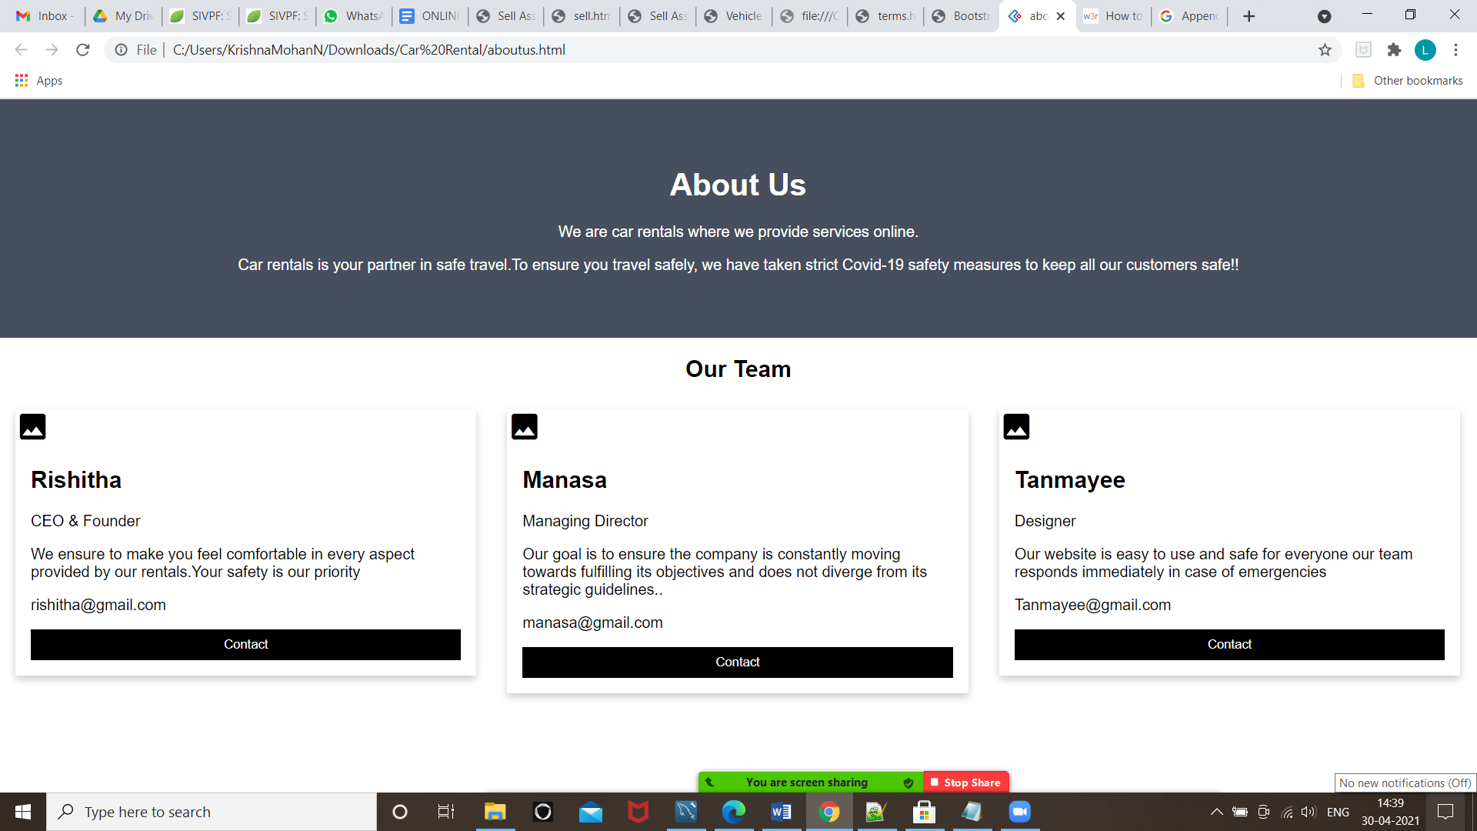

***# Contact Page:***

<!DOCTYPE html>

<html lang="en">

<head>

<meta charset="utf-8">

<meta http-equiv="X-UA-Compatible" content="IE=edge">

<meta name="viewport" content="width=device-width, initial-scale=1">

<title>Bootstrap 3 Contact Form - reusable form</title>

<!-- Latest compiled and minified CSS -->

<link rel="stylesheet" href="https://maxcdn.bootstrapcdn.com/bootstrap/3.3.7/css/bootstrap.min.css" >

<!-- Optional theme -->

<link rel="stylesheet" href="https://maxcdn.bootstrapcdn.com/bootstrap/3.3.7/css/bootstrap-theme.min.css" >

<script src="https://ajax.googleapis.com/ajax/libs/jquery/1.12.4/jquery.min.js"></script>

<link rel="stylesheet" href="form.css" >

<script src="form.js"></script>

</head>

<body >

<div class="container">

<div class="row">

<div class="col-md-6 " id="form_container">

<h2>Contact Us</h2>

<p> Please send your message below. We will get back to you at the earliest! </p>

<form role="form" method="post" id="reused_form">

<div class="row">

<div class="col-sm-12 form-group">

<label for="message"> Message:</label>

<textarea class="form-control" type="textarea" id="message" name="message" maxlength="6000" rows="7"></textarea>

</div>

</div>

<div class="row">

<div class="col-sm-6 form-group">

<label for="name"> Your Name:</label>

<input type="text" class="form-control" id="name" name="name" required>

</div>

<div class="col-sm-6 form-group">

<label for="mobilenumber"> Mobile Number:</label>

<input type="mobilenumber" class="form-control" id="mobilenumber" name="mobilenumber" required>

</div>

</div>

<div class="row">

<div class="col-sm-12 form-group">

<button type="submit" class="btn btn-lg btn-default pull-right" >Send &rarr;</button>

</div>

</div>

</form>

<div id="success_message" style="width:100%; height:100%; display:none; "> <h3>Posted your message successfully!</h3> </div>

<div id="error_message" style="width:100%; height:100%; display:none; "> <h3>Error</h3> Sorry there was an error sending your form. </div>

</div>

</div>

</div>

</body>

</html>

**Output:**

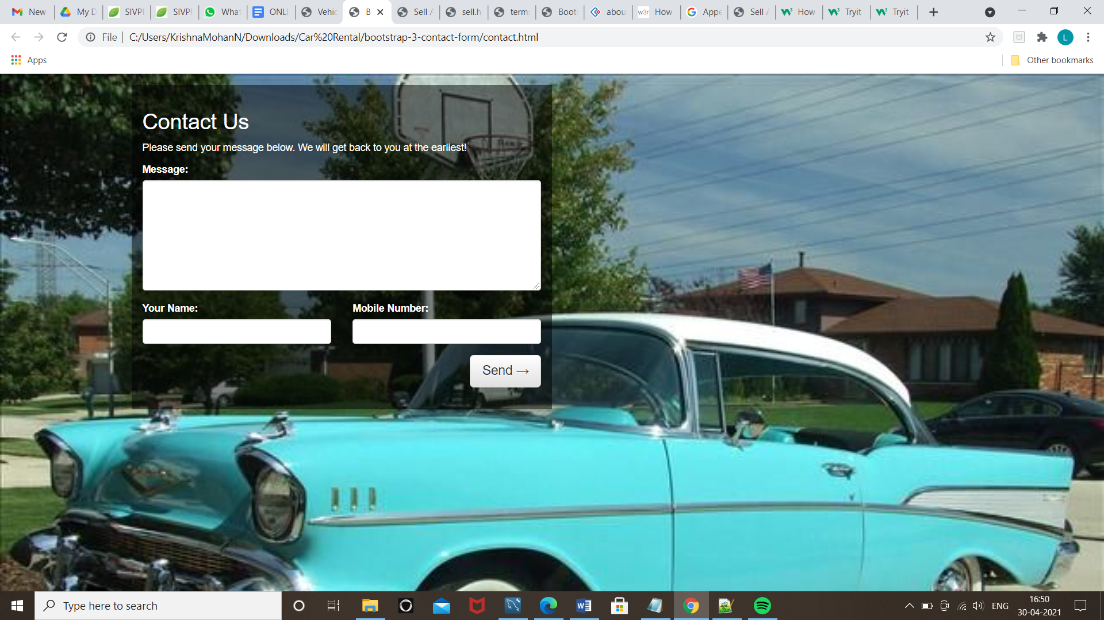

***# Terms and Conditions Page:***

<!DOCTYPE html>

<html>

<head>

<style>

body {

background-image: url('terms.png');

font-size: 26px;

font-family: "Verdana";

}

}

</style>

<body>

<h1><u>General Terms and Conditions of Vehicle Rental Agreement:</u></h1>

This instrument is valid for all companies operating under the “Unidas”, “Alamo”

and “National” brand in the rental of vehicles in the national territory, both in their

own stores or contractually authorized franchises, hereinafter simply referred to

as “Agreement”.

1.1. Accident – means the occurrence of an involuntary, casual event involving

the rental vehicle.

<br>

1.2. Risk Coverage – means the protections used to cover damages to the rental

vehicle, bodily injury of the occupants, damages and third party bodily injury.

<br>

1.3. Agreement – means this instrument, which sets forth the general rules

applicable to rentals of vehicles under the “Unidas”, “Alamo” and “National”

brands in the Brazilian territory.

<br>

1.4. Agreement Statement – means the document that identifies each actual

rental, and which also contains details of the rental vehicle, prices, term and other

rental conditions, including those contained in the information leaflet and/or tariffs

in force.

<br>

1.5. Express Return – means the service available in certain stores, upon prior

confirmation and scheduling, at which the Client may elect to return the rental

vehicle outside the store working hours.

<br>

1.6. Vehicle Rental Rate per Day – means the minimum period of twenty-four

(24) hours to rent vehicles.

<br>

1.7. Driver Rate per Day – means the minimum period of eight (8) hours to

engage the services of an Executive Driver provided by the Rental Company.

<br>

1.8. Rental Company – means the legal entity that provides the rental vehicle,

which is linked to the “Unidas”, “Alamo” and “National” brands, as duly identified

in the Agreement Statement.

<br>

1.9. Client – means the legal entity or individual so identified in the Agreement

Statement in charge of engaging the rental of vehicles.

<br>

1.10. Additional Driver(s) – are the legal entity(ies) so identified in the

Agreement Statement, which shall also be authorized to drive the rental vehicle.

</body>

</html>

**Output:**

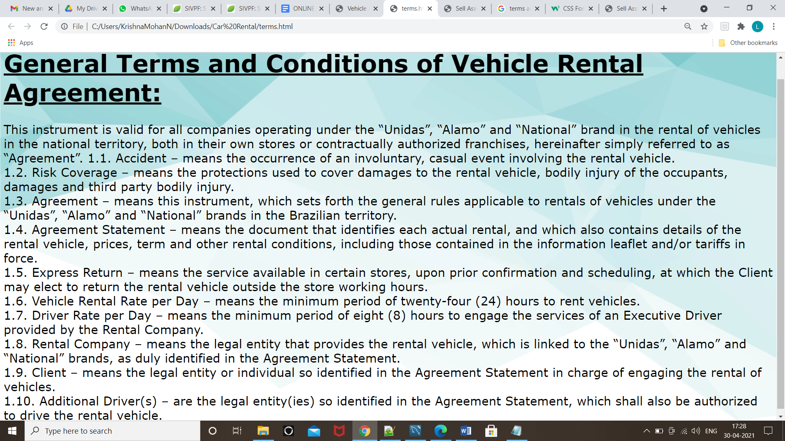

***# Privacy Policy Page:***

<!DOCTYPE html>

<html>

<head>

<style>

body {

background-image: url('privacy.jpg');

font-size: 25px;

background-repeat: no-repeat;

background-attachment: fixed;

background-size: cover;

}

h2{

color:black;

text-align:center;

}

div {

border: 1px solid black;

border-align:center;

background-color: lightblue;

width: 300px;

border: 15px solid black;

padding: 50px;

margin: 50px 50px 10px 50px;

text-align: center;

}

.center {

position: absolute;

right: 300px;

width: 800px;

border: 3px solid black;

padding: 30px 30px 30px;

}

</style>

<body>

<h2>Our Privacy Policy</h2>

<div class="center">Your privacy is very important for Car Rentals. We want you to feel secure when sending your personal data to us. Personal data constitutes any information that can be used for identification of a person. Personal data is data that Car Rental collects for provision of its services, conclusion of the agreement, identification of a person, contacting a person, or for another purpose stated below. Processing of personal data is required for effective provision of the services of Car Rental, and without provision of personal data the use of the services provided by Car Rental is not possible.

We have taken technical and organizational measures to ensure protection of your data from loss, change, theft or access by third persons. Data can be accessed only by persons authorized for that.

The above principles do not apply to processing of data of legal entities. An authorized representative of a company that orders a service is the representative of the legal entity.

Our website may contain external links to websites of third parties. When you move to those websites you must comply with their privacy policy. Our privacy policy does not cover processing of personal data if the person moved from the www.carrental.com ee website to another website via an external link.

</div>

</body>

</html>

**Output:**

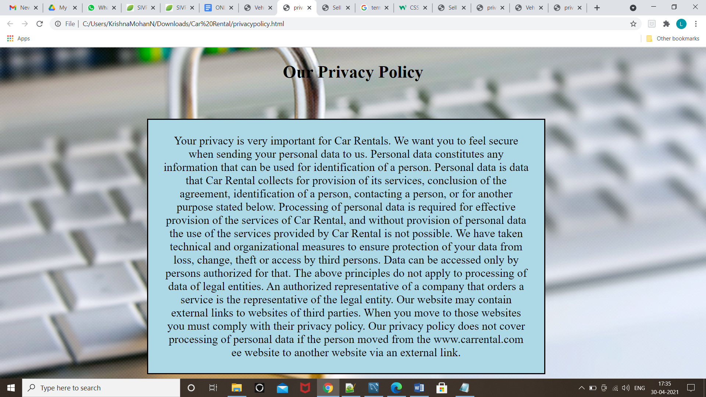

***# Signup Page:***

<!DOCTYPE html>

<html>

<head>

<meta name="viewport" content="width=device-width, initial-scale=1">

<title>CAR RENTALS</title>

<style type="text/css">

body{

font-family: Cambria;

color: black;

background-image: url("./signin.jpg");

background-repeat: no-repeat;

background-attachment: fixed;

background-size: cover;

}

table {

width: 30%;

}

td {

width: 150px;

}

input {

width: 100%;

border-style: solid;

border-color: silver;

}

.input2{

width: 100%;

border-style: solid;

border-color: silver;

}

.fit{

background-color:white;

border-radius: 5px;

padding-top: 10px;

padding-bottom: 10px;

}

.btn {

background-color: #43B494;

border-color: #43B494;

color: white;

font-weight: bold;

font-size: 14px;

width: 30%;

}

div{

color: red;

font-size: 18px;

}

body {font-family: Arial, Helvetica, sans-serif;}

/* The Modal (background) */

.modal {

display: none; /* Hidden by default */

position: fixed; /* Stay in place */

z-index: 1; /* Sit on top */

padding-top: 100px; /* Location of the box */

left: 0;

top: 0;

width: 100%; /* Full width */

height: 100%; /* Full height */

overflow: auto; /* Enable scroll if needed */

background-color: rgb(0,0,0); /* Fallback color */

background-color: rgba(0,0,0,0.4); /* Black w/ opacity */

}

/* Modal Content */

.modal-content {

background-color: #fefefe;

margin: auto;

padding: 20px;

border: 1px solid #888;

width: 80%;

}

/* The Close Button */

.close {

color: #aaaaaa;

float: right;

font-size: 28px;

font-weight: bold;

}

.close:hover,

.close:focus {

color: #000;

text-decoration: none;

cursor: pointer;

}

</style>

<script>

function checkname(){

var n=document.getElementById('name').value;

var error="";

if(n.length<6){

error="**Name should contain atleast 6 characters";

document.getElementById("ner").innerHTML=error;}

for(var i=0;i<n.length;i++){

if(n[i]=='0'||n[i]=='1'||n[i]=='2'||n[i]=='3'||n[i]=='4'||n[i]=='5'||n[i]=='6'||n[i]=='7'||n[i]=='8'||n[i]=='9'){

error=error+"\n"+"Name should not contain numbers";

document.getElementById("ner").innerHTML=error;

break;}

}

document.getElementById("ner").innerHTML=error;

}

function checkname3(){

var n=document.getElementById('name').value;

var error="";

if(n.length<6){

error="**Username should contain atleast 6 characters";

document.getElementById("ner1").innerHTML=error;}

for(var i=0;i<n.length;i++){

if(n[i]=='0'||n[i]=='1'||n[i]=='2'||n[i]=='3'||n[i]=='4'||n[i]=='5'||n[i]=='6'||n[i]=='7'||n[i]=='8'||n[i]=='9'){

error=error+"\n"+"name should not contain numbers";

document.getElementById("ner").innerHTML=error;

break;}

}

document.getElementById("ner1").innerHTML=error;

}

function check2(){

var error="";

var n1=document.getElementById('password').value.length;

if(n1<8){

error="**Password should not be less than 8 characters";

document.getElementById("npa").innerHTML=error;}

document.getElementById("npa").innerHTML=error;

}

function checkp()

{

var error="";

var n1=document.getElementById('password').value;

var n2=document.getElementById('pwd2').value;

if(n1 != n2) {

error="**passwords are not same";

document.getElementById("npa1").innerHTML = error;}

document.getElementById("npa1").innerHTML = error;

}

function check(){

var n=document.getElementById('PhoneNumber').value.length;

var error="";

if(n!=10){

error="**Phone number must contain 10 digits"

document.getElementById("nnu").innerHTML=error;

}

document.getElementById("nnu").innerHTML=error;

}

function checkname4(){

var n=document.getElementById('license').value;

}

function checkname5(){

var n=document.getElementById('Address').value;

}

</script>

</head>

<body>

<span style="margin-left: 1300px;">

<a href="./Homepage.html">

<img src="./home_icon.png" width="80px">

</a>

</span>

<center>

<form>

<p style="font-weight: bold; font-size: 250%">CAR RENTALS</p>

<table>

<tr>

<td colspan="6" style="text-align: center; padding-bottom: 20px;

font-size: 150%;">SIGN UP</td>

</tr>

<tr>

<td colspan="3" style="padding-right: 5px;">

<input type="text" id="name" name="" placeholder="

Name" class="fit" onchange="checkname()" >

<br><div id="ner"></div>

</td>

</tr>

<tr>

<td colspan="6">

<input type="username" id="Username" placeholder=" Username"

class="fit"onchange="checkname3()" >

<br><div id="nem"></div>

</td>

</tr>

<tr>

<td colspan="6">

<input type="password" id="password" name="" placeholder="

Password (mininum 8 characters)" class="fit" onchange="check2()">

<br><div id="npa"></div></td>

</td>

</tr>

<tr>

<td colspan="6">

<input type="password" id="pwd2" name="" placeholder="

Repeat Password" class="fit" onchange="checkp()">

<br><div id="npa1"></div></td>

</td>

</tr>

<tr>

<td colspan="6">

<input type="text" id="MobileNumber" placeholder=" MobileNumber" class="fit" onchange="check()">

<br><div id="nnu"></div></td>

</td>

</tr>

<tr>

<td colspan="6">

<input type="license" id="License Number" placeholder=" License Number"

class="fit"onchange="checkname4()" >

<br>

</td>

</tr>

<tr>

<td colspan="6" rowspan="3">

<input type="Address" id="Address" placeholder="Address"

class="fit"onchange="checkname5()" >

<br>

</td>

</tr>

</table>

</form>

<button id="myBtn">Create Account</button>

<div id="myModal" class="modal">

<div class="modal-content">

<span class="close">&times;</span>

<p>Account created Successfully</p>

</div>

</div>

<script>

var modal = document.getElementById("myModal");

var btn = document.getElementById("myBtn");

var span = document.getElementsByClassName("close")[0];

btn.onclick = function() {

modal.style.display = "block";

}

span.onclick = function() {

modal.style.display = "none";

}

window.onclick = function(event) {

if (event.target == modal) {

modal.style.display = "none";

}

}

</script>

</a>

<p style="font-size: 115%">Already a member ? <a href="file:///C:/Users/KrishnaMohanN/Downloads/Car%20Rental/login.html">SignIn here</a></p>

</center>

</body>

</html>

**Input:**

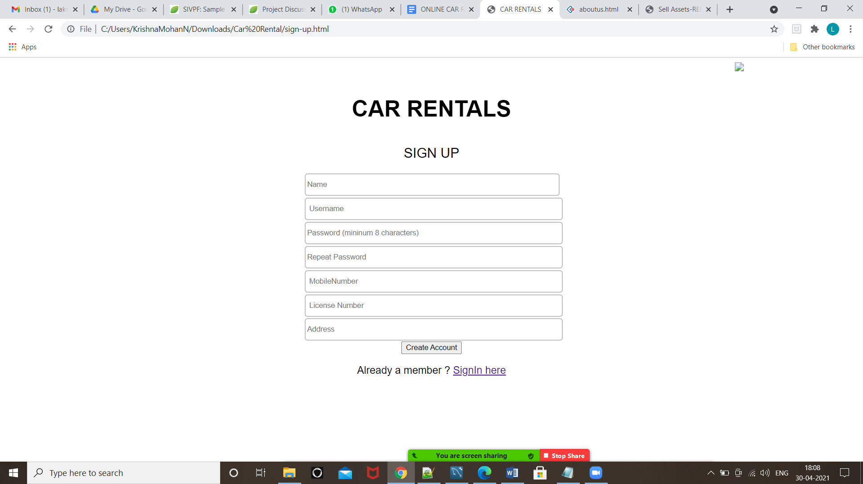

**Output:**

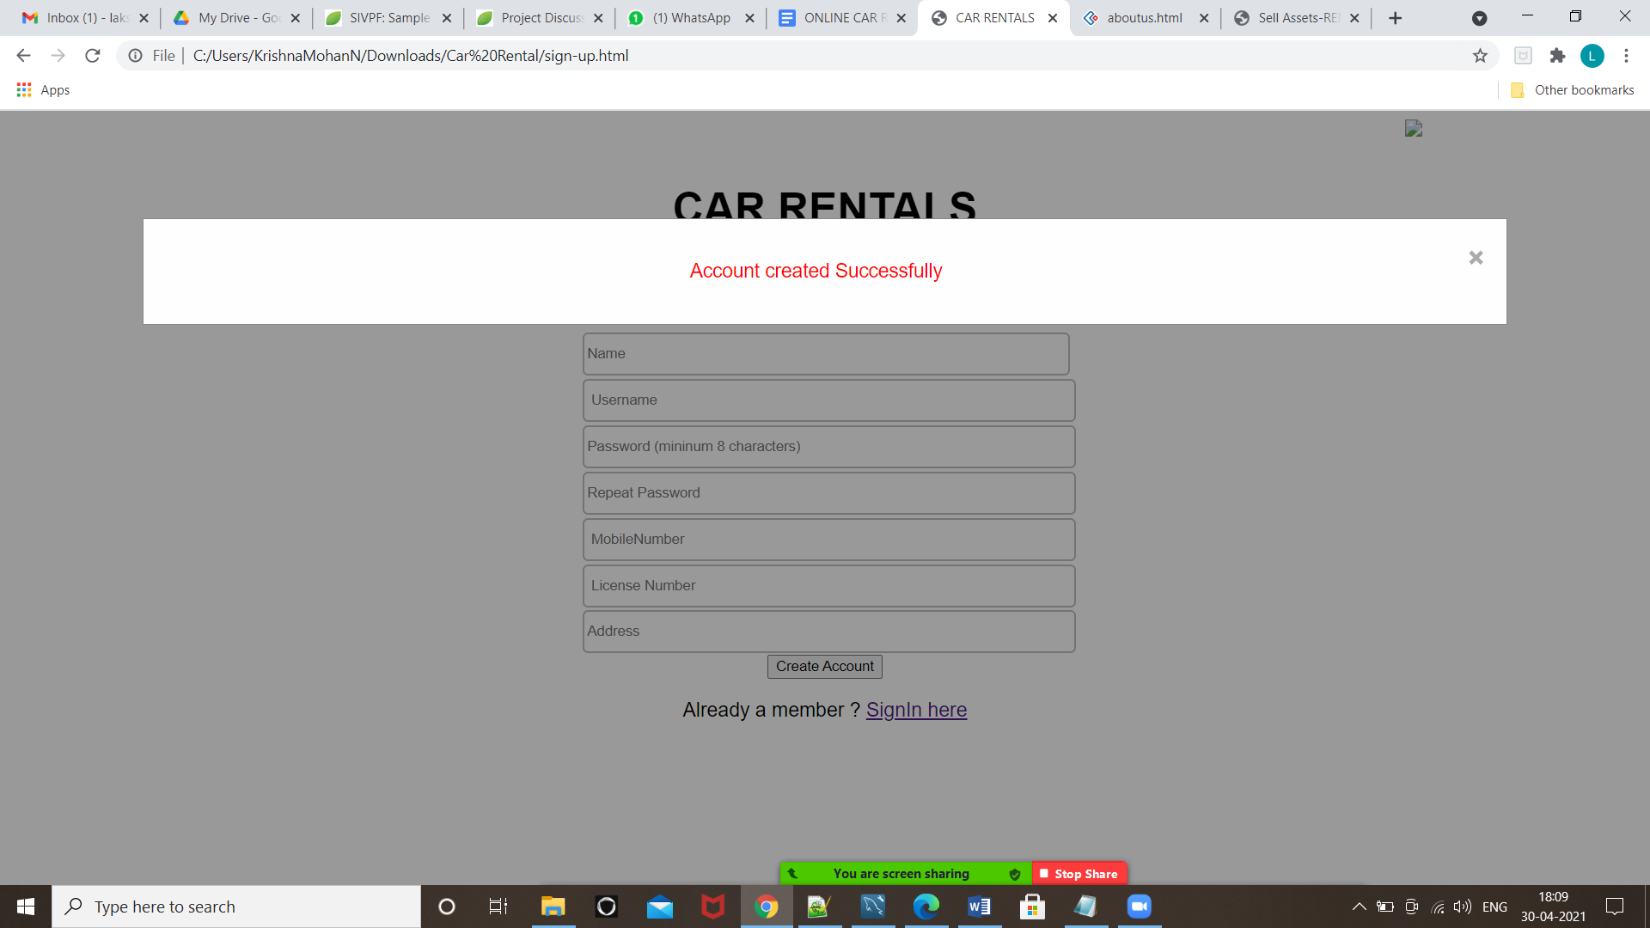

***# Login Page:***

<!DOCTYPE html>

<html>

<head>

<title>CAR RENTALS</title>

<style type="text/css">

body{

font-family: Cambria;

color: black;

background-image: url("./signin.jpg");

background-repeat: no-repeat;

background-attachment: fixed;

background-size: cover;

}

table {

width: 30%;

border: none;

}

td {

width: 150px;

}

input {

width: 100%;

border-style: solid;

border-color: silver;

}

.fit{

background-color:white;

border-radius: 5px;

padding-top: 10px;

padding-bottom: 10px;

}

.btn {

background-color: #43B494;

border-color: #43B494;

color: white;

font-weight: bold;

font-size: 14px;

width: 100%;

}

</style>

</head>

<body>

<span style="margin-left: 1300px;">

<a href="./Homepage.html">

<img src="./home_icon.png" width="80px">

</a>

</span>

<center>

<br><br><br>

<form>

<p style="font-weight: bold; font-size: 250%">CAR RENTALS</p>

<table>

<tr>

<td colspan="6" style="text-align: center; padding-bottom: 20px; font-size:

150%;">LOGIN</td>

</tr>

<tr>

<td colspan="6">

<input type="E-mail" name="" placeholder=" Email address" class="fit"

required autofocus>

</td>

</tr>

<tr>

<td colspan="6">

<input type="password" name="" placeholder=" Password" class="fit"

required>

</td>

</tr>

</table>

</form>

<a href= "file:///C:/Users/KrishnaMohanN/Downloads/Car%20Rental/Cars.html">

<button class="btn fit" type="Submit" style="width: 30%; border-radius: 5px; color:

white;">Login</button>

</a>

<p style="font-size: 115%">Not a member ? <a

href="file:///C:/Users/KrishnaMohanN/Downloads/Car%20Rental/sign-up.html">Register here</a></p>

</center>

</body>

</html>

**Output:**

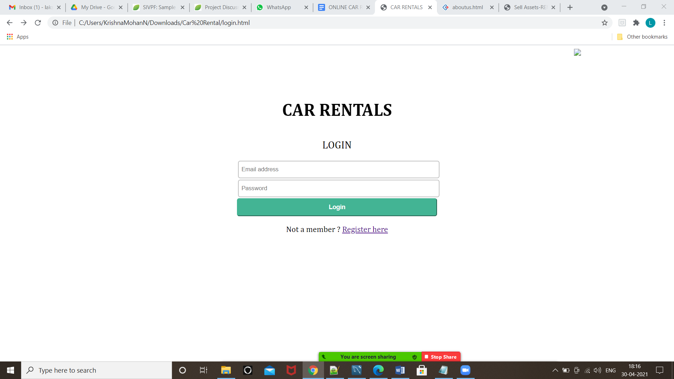

**Database:**

1. **User Table:**

* **Input:**

create database car;

use car;

create table user

( user_id int auto_increment,

user_name varchar(20) NOT NULL,

user_mobile varchar(10) NOT NULL,

user_address varchar(255),

dno smallint(255),

city varchar(255),

state varchar(255),

country varchar(255),

post_code int(11),

unique(user_mobile),primary key(user_id)

);

* **Output- Number of People Registered**

**Users:**

select * from user;

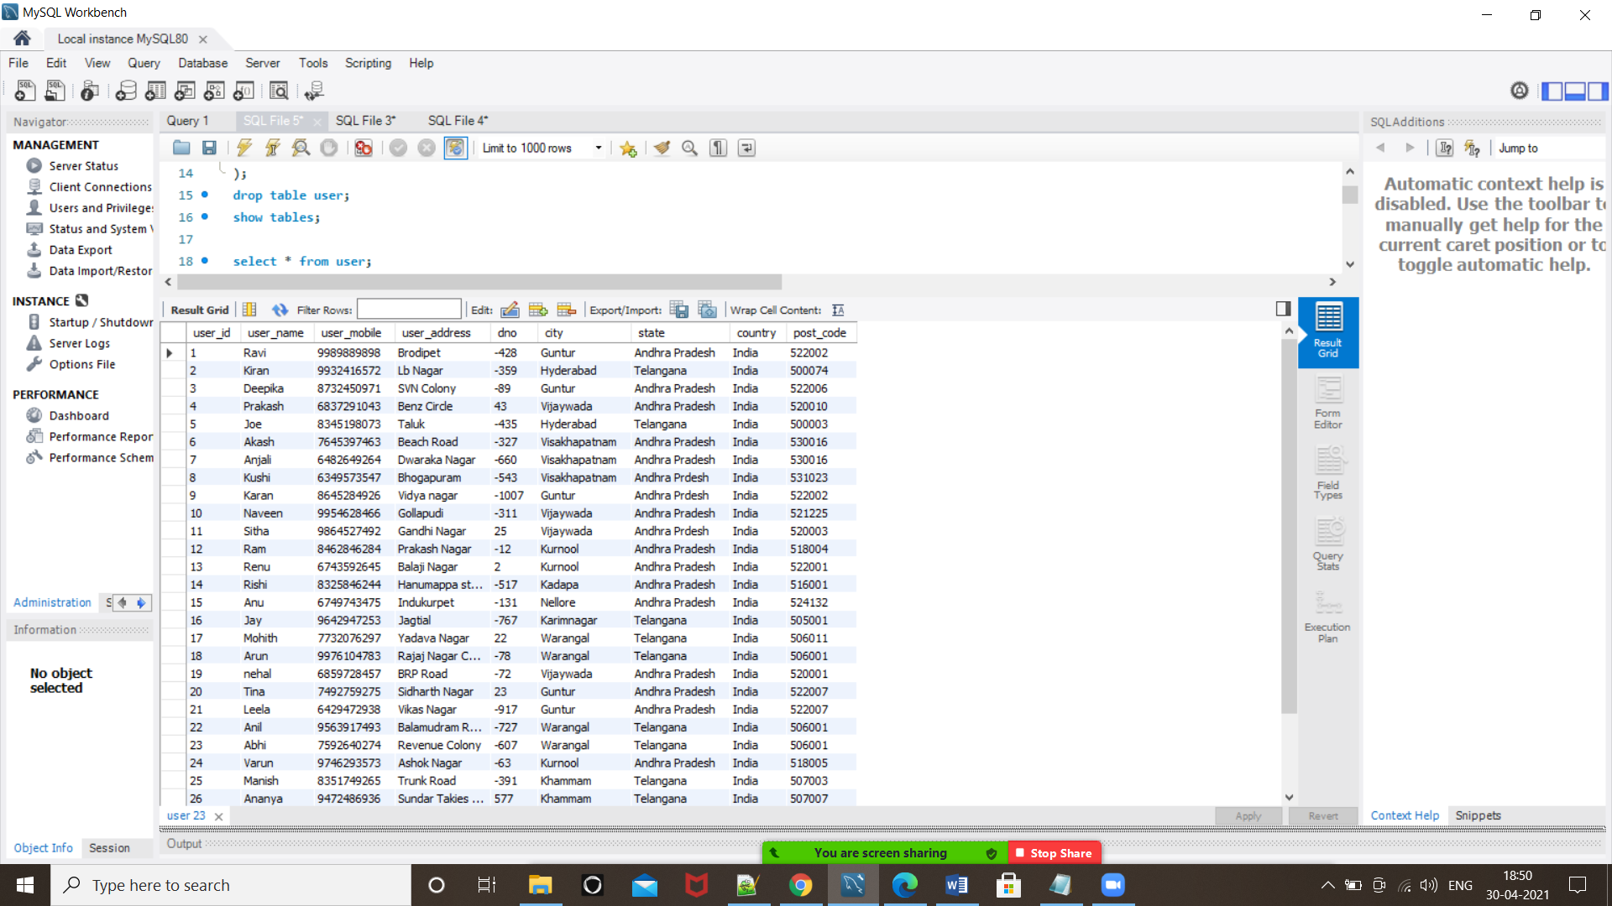

1. **Permission Table:**

* **Input:**

create table permission

( user_yob year not null,

user_license varchar(20),

primary key(user_license),

user_id int,

CONSTRAINT FK_userpermission FOREIGN KEY (user_id)

REFERENCES user(user_id)

);

* **Output- Users who got permission to rent a car.**

select user_id,user_yob+18,user_license from permission;

select user_name, user_mobile,user_yob,user_license from user, permission where user.user_id=permission.user_id and user_yob<=2021;

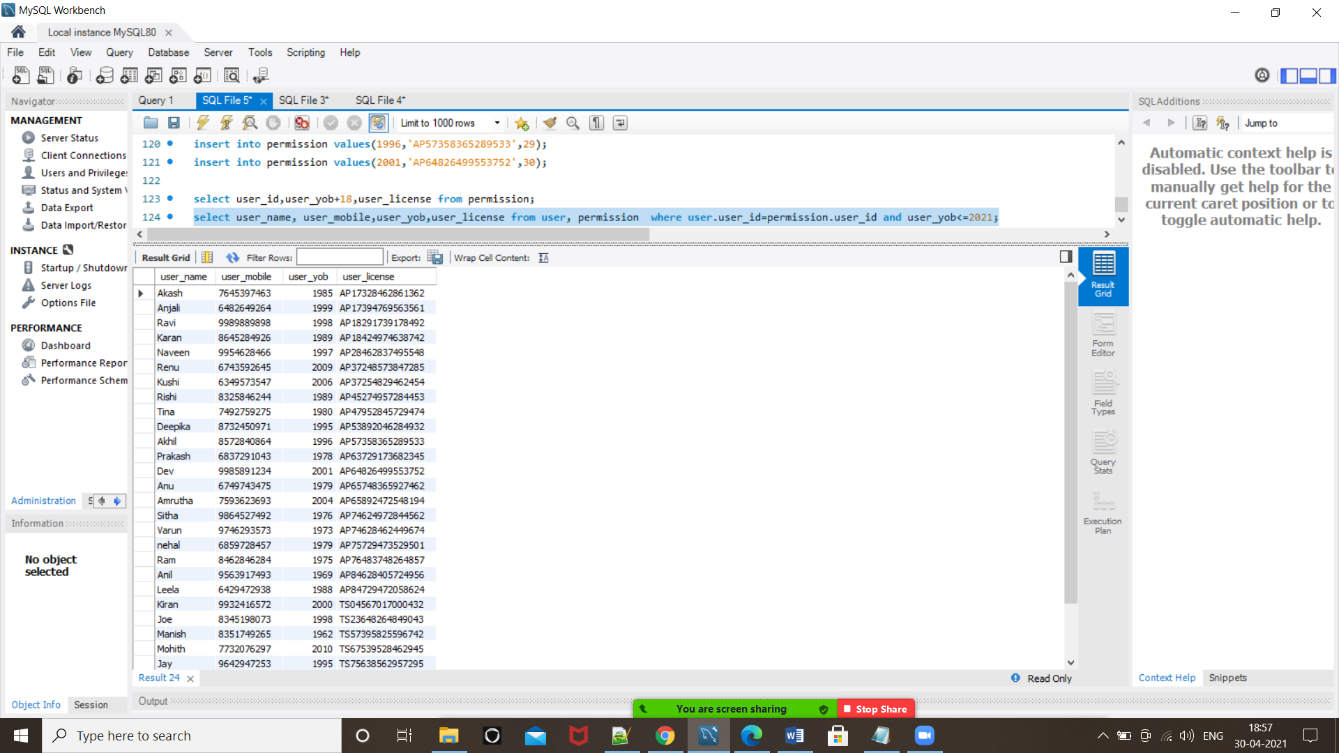

***# Cars Page:***

<!DOCTYPE html>

<html lang="en">

<head>

<meta charset="UTF-8">

<meta name="viewport" content="width=device-width, initial-scale=1.0">

<title> CAR RENTALS </title>

<link rel="stylesheet" href="css/style.css">

<link rel="stylesheet" href="css/fa/css/all.min.css">

<link href="https://cdn.jsdelivr.net/npm/bootstrap@5.0.0-beta2/dist/css/bootstrap.min.css" rel="stylesheet" integrity="sha384-BmbxuPwQa2lc/FVzBcNJ7UAyJxM6wuqIj61tLrc4wSX0szH/Ev+nYRRuWlolflfl" crossorigin="anonymous">

<style>

img{

width: 30%;

height:300px;

float: left;

margin: 1.66%;

}

h1 {

font-family: 'Brush Script MT', cursive;

text-align:center;

}

</style>

</style>

</head>

<body>

<a name="top"></a>

<header class="header">

<h1 id="logo">Select your dream Car</h1>

</header>

<main class="main">

<h1>Select on the car for more Information </h1>

<section class="shop">

<div class="box">

<p><a href="file:///C:/Users/KrishnaMohanN/Downloads/Car%20Rental/Cars%20Available/2020-i

nfiniti-qx60-brochure-en.pdf"><img src="Infiniti qx60.jpg" alt="Infiniti qx60"></a></p>

</div>

<div class="box">

<p><a href="file:///C:/Users/KrishnaMohanN/Downloads/Car%20Rental/Cars%20Available/2020-i

nfiniti-qx60-brochure-en.pdf"><img src="https://www.india.ford.com/content/ford/in/en_in/home/cars/aspire/jcr:content/par/hotspots/imageComponent/image.imgs.full.high.jpg" alt="Infiniti qx60"></a></p>

</div>

<div class="box">

<p><a href="file:///C:/Users/KrishnaMohanN/Downloads/Car%20Rental/Cars%20Available/2020-i

nfiniti-qx60-brochure-en.pdf"><img src="https://imgd.aeplcdn.com/664x374/n/55reasa_1459072.jpg?q=85" alt="Infiniti qx60"></a></p>

</div>

<div class="box">

<p><a href="file:///C:/Users/KrishnaMohanN/Downloads/Car%20Rental/Cars%20Available/2020-i

nfiniti-qx60-brochure-en.pdf"><img src="https://mcmscache.epapr.in/post_images/website_341/post_16133673/thumb.jpg" alt="Infiniti qx60"></a></p>

</div>

<div class="box">

<p><a href="file:///C:/Users/KrishnaMohanN/Downloads/Car%20Rental/Cars%20Available/2020-i

nfiniti-qx60-brochure-en.pdf"><img src="https://i.pinimg.com/736x/ca/12/8c/ca128c77a4d1e7c751522edbb1d37d3b.jpg" alt="Infiniti qx60"></a></p>

</div>

<div class="box">

<p><a href="file:///C:/Users/KrishnaMohanN/Downloads/Car%20Rental/Cars%20Available/2020-i

nfiniti-qx60-brochure-en.pdf"><img src="https://imgd.aeplcdn.com/1200x900/cw/ec/25833/Honda-WRV-Exterior-118956.jpg?wm=0&q=85" alt="Infiniti qx60"></a></p>

</div>

</main>

</body>

</html>

**Output:**

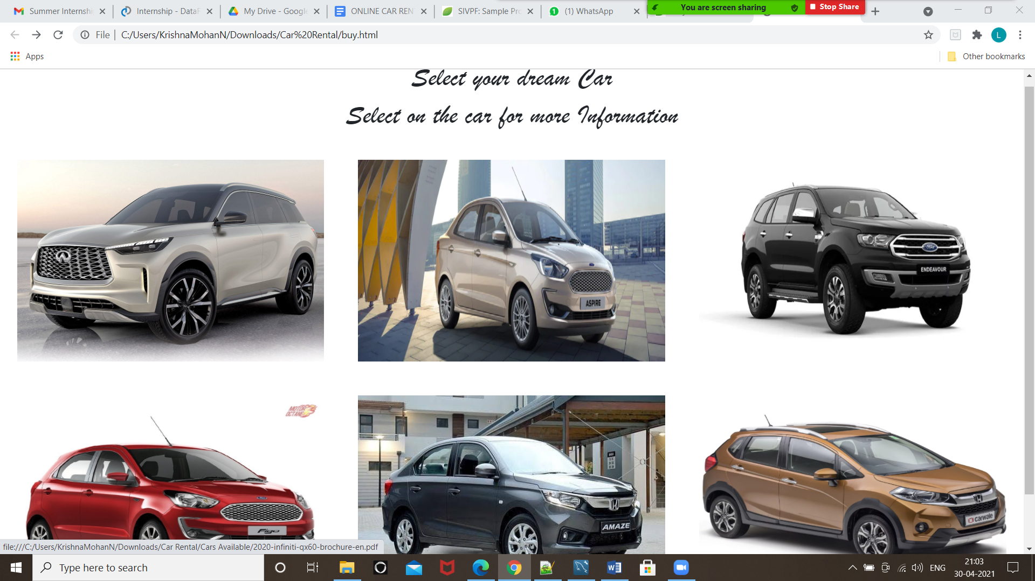

**Output for more information of car:**

**Aspire Ford:**

***Choose your path.Why follow.***

The ford Aspire is here to set you apart.Its powerful engine propels you ahead in life.Its Stylish design leaves a lasting impression.Its technology and safety features put your mind at ease. So get set to drive the Ford aspire. Made for those who don't believe in following others, but making their own way.

**Ford Endeavour:**

***Make everyday epic***

Specialty:Engineered for extraordinary, the Ford Endeavour is built to take on the most epic adventures and conquer tough terrains with ease.

**Figo Ford:**

***Play smart.Why follow***

speciality:The Ford Figo is designed to perfectly fit in your smart world. Its energetic design and powerful engine are always ready to fuel your fast-paced lifestyle. Its smart technology and safety features add fun and ease to every journey. Giving you the confidence to take on life and manoeuvre through twists and turns in a smart way!

**Infiniti:**

***Empower the drive***

Speciality:the technology to enhance your senses, striking design

that demands a response and performance that makes you feel more alive.

Prepare to experience the road as it was intended.

**Honda Amaze:**

***The Big move.***

Speciality:Nothing declares you've made it big like the Honda Amaze. An Aggressive front, imposing shape and sculpted contours all come together in an unmissable, bold, solid design. Guaranteed to make you stand out from the crowd and leave a big impression

**Forte Family**

***A simple guide to help you decide.***

Speciality: Forte with your name on it, with a lineup that

includes the super sleek, award-winning Forte sedan and

the sporty, versatile, all-new Forte5. Whichever you choose,

you’ll be calling Forth your Best Small Car.

**Hyundai Elantra**

***The hi-tech drive is here***

Speciality:A symbol of prestige and success, the new ELANTRA has wowed the world for many decades. Unmatched styling, supreme precision, there are countless reasons why this masterpiece is considered an epitome of finesse. To continue this fine legacy, the new ELANTRA is here. A sixth-generation variant that is bolder, sportier and definitely more desirable, this premium sedan comes powered with high-end connectivity and new advanced features. Go ahead, let this award-winning global favourite into your world. It is, in every way, as inspiring as your journey

**Hyundai Venue:**

***Connected to excitement***

Speciality:The Hyundai Venue has been designed to perfectly suit your trendy personality and on-the-move urban lifestyle. Create new experiences and stay ahead of the crowd with the stunning new sport trim. The Venue is equipped with India's first Intelligent Manual Transmission (iMT) to give an unparalleled driving experience with smooth transitions and ensures that the power is in your hands so that every journey you take is filled with excitement.

**Honda WR-V:**

***The new WR-V is Darling to go***

Speciality:With new action-packed features, aggressive front grille and led eyes that shine with excitement. The new WR-V is darling to go.

**Database:**

1. **Carsavail:**

**Input:**

create table caravail

(car_id varchar(22) primary key,

car_model varchar(22),

car_company varchar(22),

car_availability char(5),

car_reg_no varchar(22)

);

**Output:**

select * from caravail;

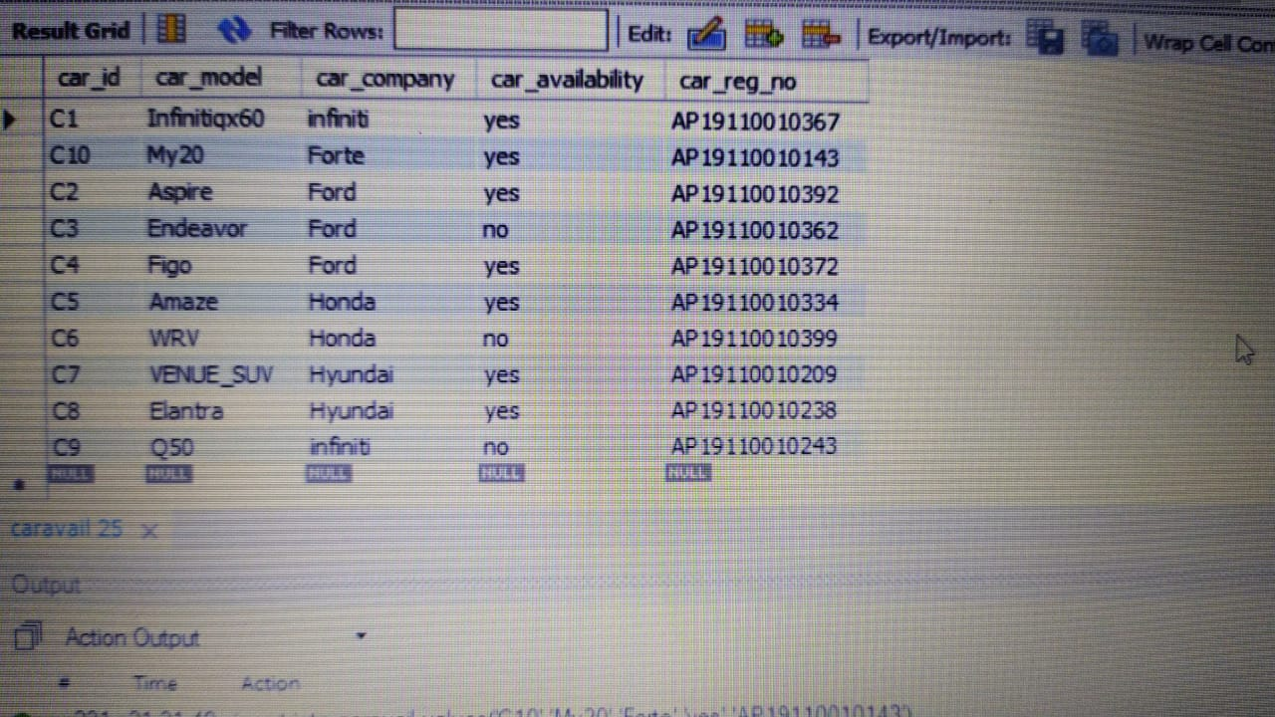

***#Car Booking.html***

<!DOCTYPE html>

<html lang="en">

<head>

<meta http-equiv="Content-Type" content="text/html; charset=utf-8" />

<title>Car Booking</title>

<link rel="stylesheet" href="css/style.css">

<link rel="stylesheet" href="css/fa/css/all.min.css">

<link href="https://cdn.jsdelivr.net/npm/bootstrap@5.0.0-beta2/dist/css/bootstrap.min.css" rel="stylesheet" integrity="sha384-BmbxuPwQa2lc/FVzBcNJ7UAyJxM6wuqIj61tLrc4wSX0szH/Ev+nYRRuWlolflfl" crossorigin="anonymous">

</head>

<body class="bg-light">

<div class="container">

<header class="header">

<br>

</header>

<br>

<hr>

<br>

<section class="top">

<img src="https://www.izmostock.com/wp-content/uploads/2018/04/izmostock_MainBanner_05.jpg" alt="banner" class="banner" width="100%" height="90%">

</section>

<fieldset>

<br>

<br>

<h2>

<U><b>Details Required:</b></U>

</h2>

<form class="needs-validation " method="post" action="sell.php" enctype="multipart/form-data">

<p>

<label for="Name">Name : </label>

<input type="text" class="form-control" name="name" placeholder="Enter Name" value="" required>

</p>

<p>

<label for="address">Address/Location : </label>

<input type="text" class="form-control" name="address" placeholder="Enter address" value="" required>

<div class="invalid-feedback">

Address required.

</div>

</p>

<p>

<label for="contact_number">Contact Number : </label>

<input type="number" class="form-control" name="contact_number" placeholder="Contact Number" value="" required>

<div class="invalid-feedback">

Phone Number required.

</div>

</p>

<p>

<label for="company">Company : </label>

<input type="text" class="form-control" name="company" placeholder="Company you want to choose" value="" required>

<div class="invalid-feedback">

Company name in number format.

</div>

</p>

<p>

<label for="model">Model : </label>

<input type="text" class="form-control" name="name" placeholder="Enter the model of the car you want to choose" value="" required>

<div class="invalid-feedback">

Model is required.

</div>

</p>

<p>

<label for="mail">Email ID : </label>

<input type="text" class="form-control" name="mail" placeholder="Mail ID" value="" required>

</p>

<p>

<label for="file">License ID : </label>

<input type="file" class="form-control" name="file" placeholder="Upload here" value="" required>

</p>

<p>&nbsp;</p>

<p>

<input type="submit" name="Submit" id="Submit" value="Submit" class="btn btn-primary btn-lg btn-block">

</p>

</form>

</fieldset>

</div>

</body>

</html>

**Output:**

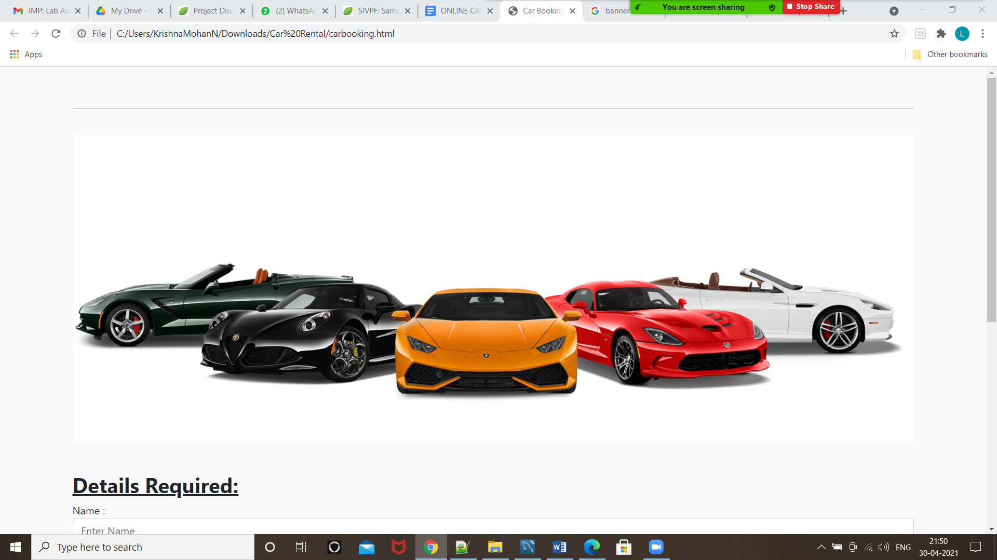

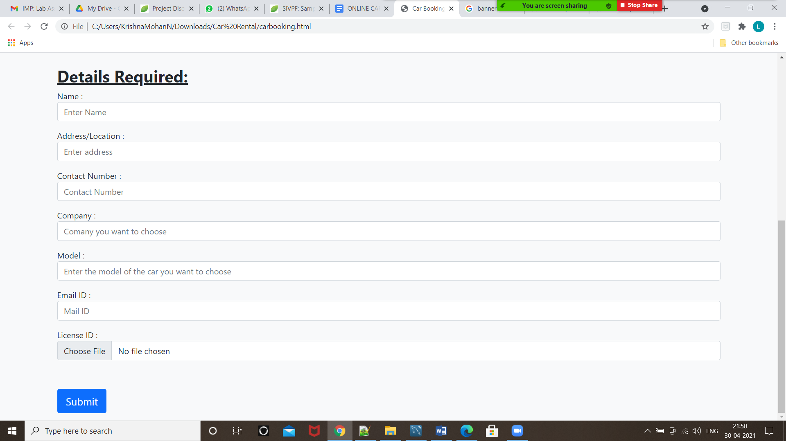

**Database:**

**4.Bookings:**

**Input:**

create table bookings

( bookings_id int auto_increment primary key,

user_license varchar(20),

car_id varchar(22),

CONSTRAINT FK_caravailbookings FOREIGN KEY (car_id)

REFERENCES caravail(car_id)

);

**Output:**

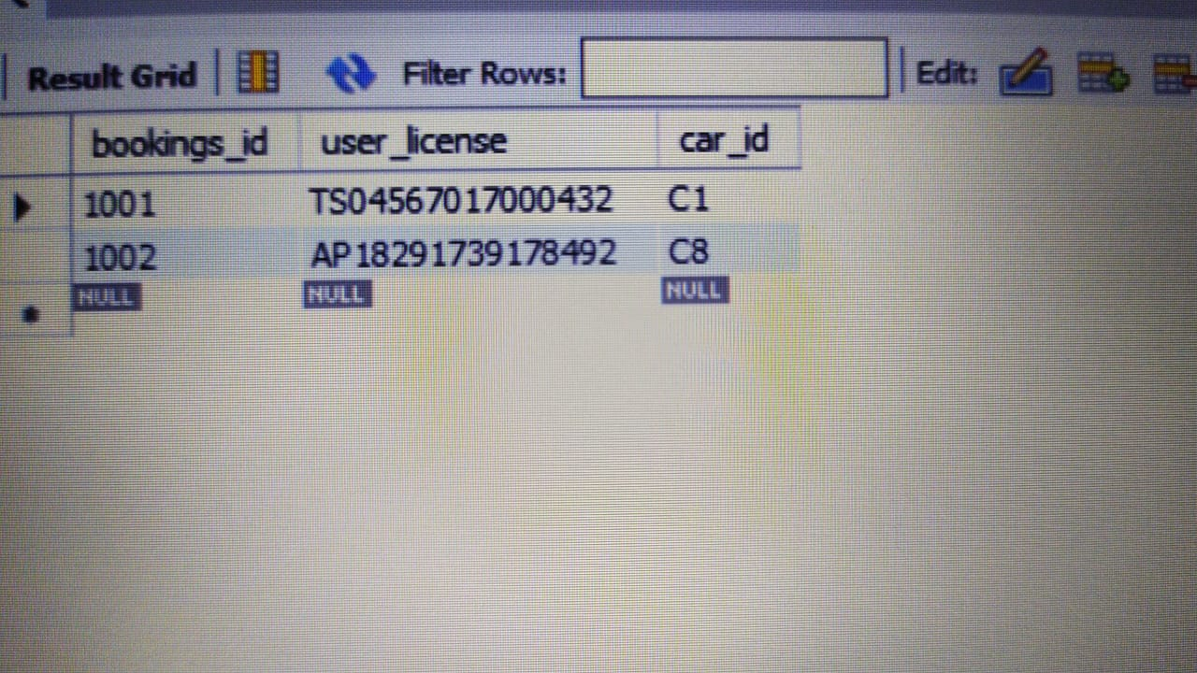

**9.Conclusion and recommendations:**

Car rental business has emerged with new goodies compared to the past experience where every activity concerning car rental business is limited to a physical location only. Even though the physical location has not been totally eradicated; the nature of functions and how these functions are achieved has been reshaped by the power of the internet. Nowadays, customers can reserve cars online, rent cars online, and have the car brought to their doorstep once the customer is a registered member or go to the office to pick the car.

The web based car rental system has offered an advantage to both customers as well as Car Rental Company to efficiently and effectively manage the business and satisfies customers’ needs at the click of a button.

**10.Future Scope:**

* One who doesn't want to use public transport during the time of pandemic can use this service.
* Those who do not have their own car or owners of damaged vehicles who are awaiting repair or insurance compensation.

**11.References:**

**“**[**https://www.w3schools.com/sql/**](https://www.w3schools.com/sql/)**”**

**“**[**https://www.w3schools.com/css/default.asp**](https://www.w3schools.com/css/default.asp)**”**

**“https://www.cs.uct.ac.za/mit_notes/software/htmls/ch06s07.html#:~:text=As%20described%20previously%2C%20context%20diagrams,view%E2%80%9D%20of%20the%20context%20diagram.”**

**12.Appendices:**

The main purpose of our project is to create a platform online through which people can rent the cars and make use of them at any time. The main purpose of the Car Rental System is to manage the details of Car, Payment, Customer, Supplier, etc.

Finally, we would like to thank our mentor, friends for your continuous encouragement, suggestions and your constructive criticism that have contributed to the evaluation of ideas on our project.